Setting up ID Tracker

1. Preferred Platform : Windows
2. Download Matlab Compiler Runtime 8.3 and executable of IDTracker from <http://www.idtracker.es/download>

There are two executables

1. Idtracker.exe - Main Application which does the tracking part
2. IdPlayer.exe - Visualizes previously tracked videos

Basic Flow

Step 1.

Click on Idtracker.exe, it will ask to select a video for tracking

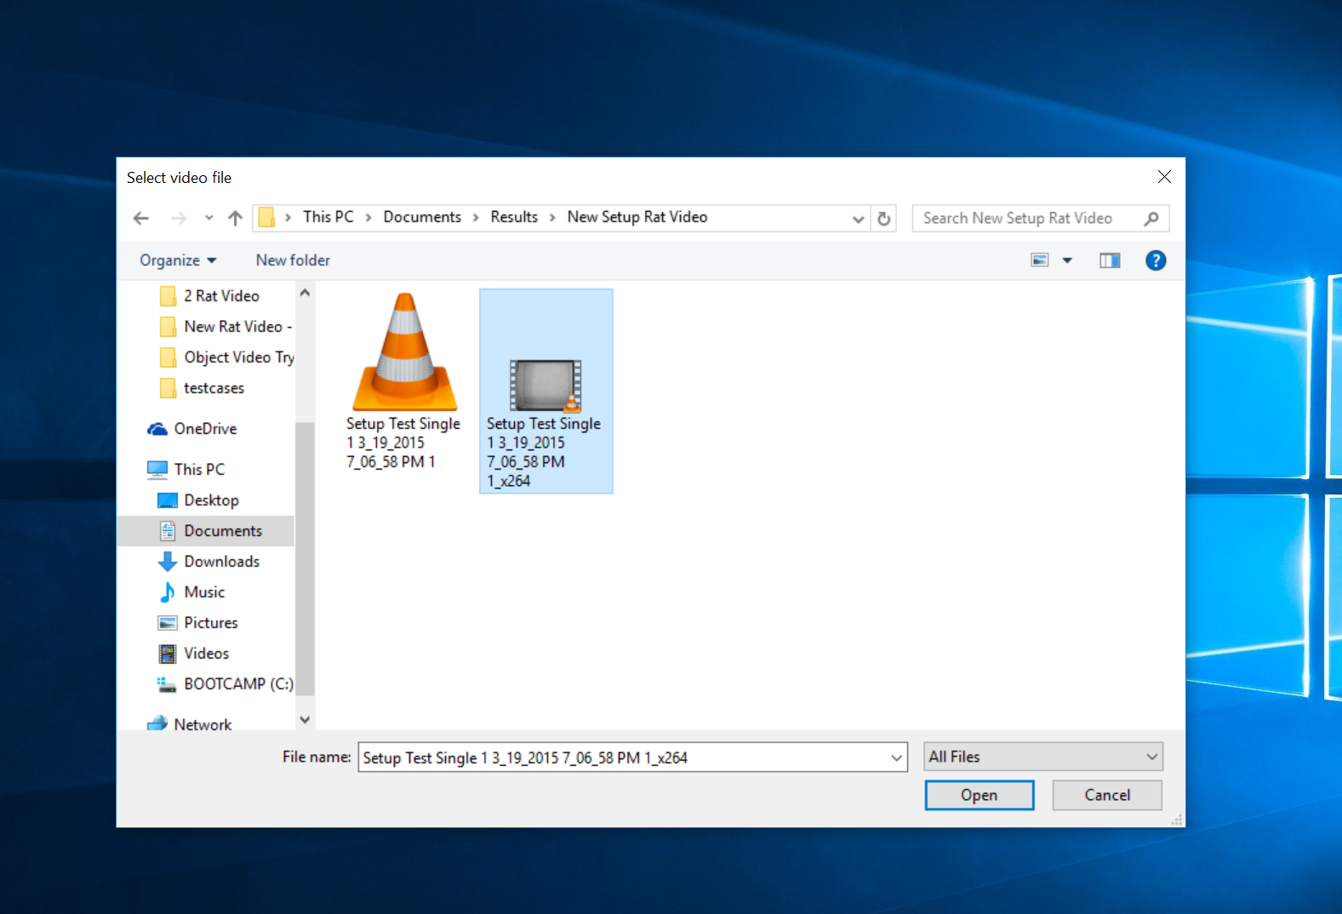

Step 2.

On selecting the video, it will open basic idtracker window with default settings like this.

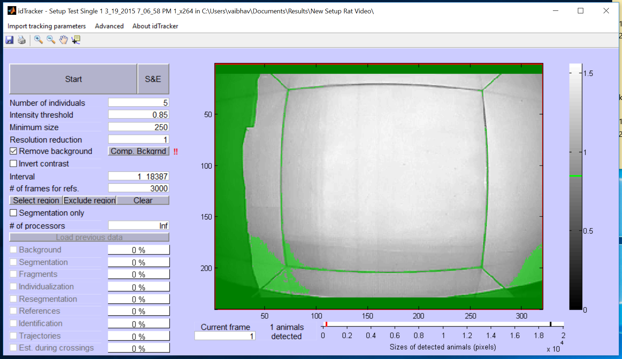

Step 3.

Update the following values for our Rat Project

Number of Individuals - 1 or 2 depending on the video

Intensity threshold - 0.85 is fine, we can lower it for blurry videos

Minimum Size - 100-120 seems to give good results

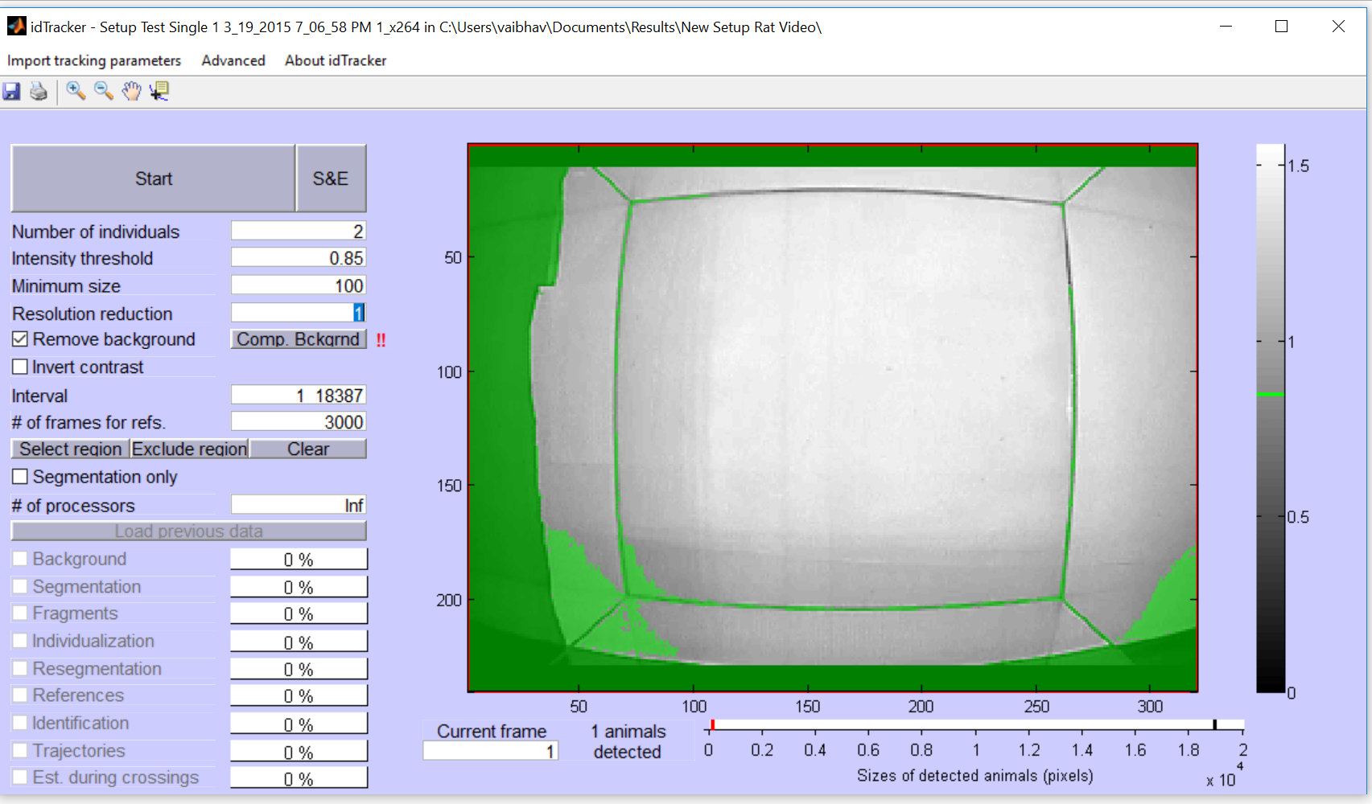

Step 4 (Optional)

Depending on the video, we can also define our region of interest as well.



Step 5. Click on Start after this. Depending on the size of the video, it can take from minutes to hour for tracking to finish.

Once tracking is finished, we can see the following screen which tells the reliability of tracking.

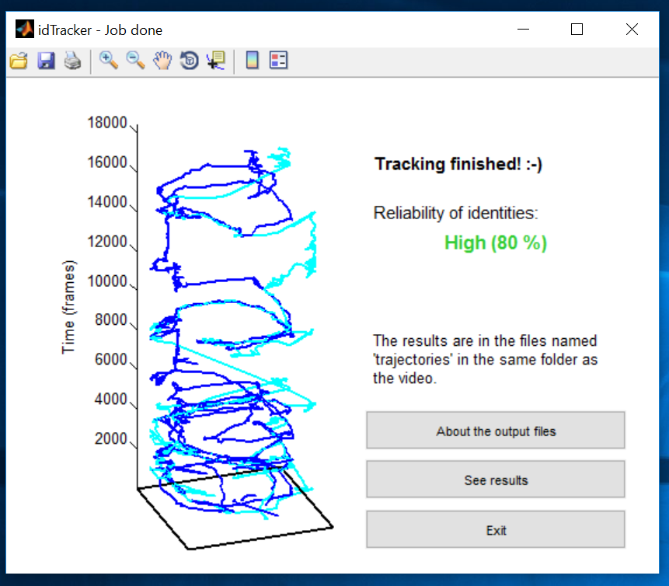

We can then click on “See Results” to visualize tracking using Idplayer,

It will open the following screen

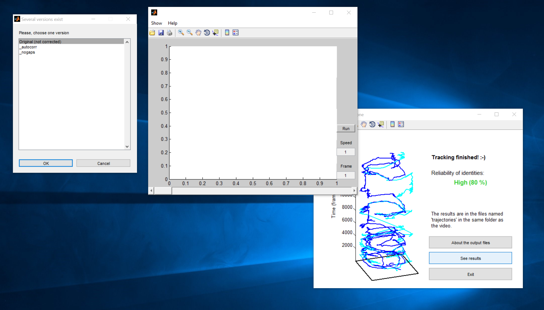

We will choose No gaps result for now.